**Research on Microsoft HoloLens**

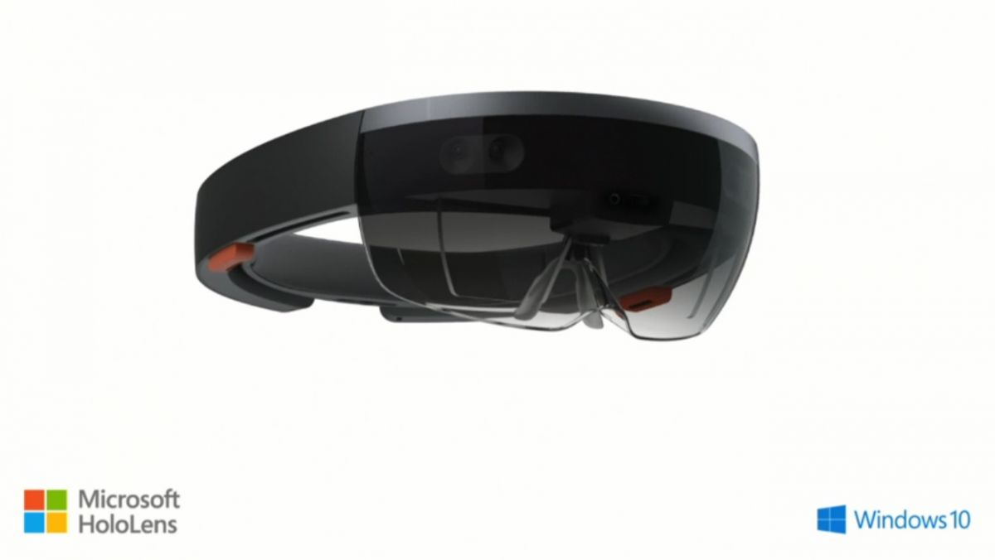

**Brief introduction about Microsoft HoloLens**

Microsoft HoloLens is the premier device for Windows Holographic; enabling a mixed reality platform. It uses various sensors, a high-definition stereoscopic 3D [optical head-mounted display](https://en.wikipedia.org/wiki/Optical_head-mounted_display), and spatial sound to allow for augmented reality applications, with a [natural user interface](https://en.wikipedia.org/wiki/Natural_user_interface) that the user interacts with through gaze, voice, and hand gestures. The Gaze tracking techniques such as head-tracking allows the user to bring application focus to whatever the user is looking at. Elements can be selected via an "air tap" gesture akin to [clicking](https://en.wikipedia.org/wiki/Point_and_click) an imaginary mouse. It has all the functionalities of a computer; such as browsing the web.

A collection of applications will be provided for free for developers purchasing the Microsoft HoloLens Developer Edition. Applications available at launch include:

* HoloStudio, a full-scale 3D modelling application by Microsoft with 3D print compatibility.
* Actiongram, an application for staging and recording short video clips of simple mixed-reality presentations using pre-made 3D virtual assets, will be released in summer 2016 in the United States and Canada.
* An implementation of the [Skype](https://en.wikipedia.org/wiki/Skype) telecommunications application by Microsoft
* HoloTour, an [audiovisual](https://en.wikipedia.org/wiki/Audiovisual" \o "Audiovisual) [three-dimensional virtual tourism](https://en.wikipedia.org/wiki/Three-dimensional_virtual_tourism) application
* Fragments, a high-tech crime thriller [adventure game](https://en.wikipedia.org/wiki/Adventure_game) developed by Microsoft and [Asobo Studio](https://en.wikipedia.org/wiki/Asobo_Studio" \o "Asobo Studio), in which the player engages in crime-solving
* Young Conker, a [platform game](https://en.wikipedia.org/wiki/Platform_game) developed by Microsoft and Asobo Studio, featuring a young version of [Conker the Squirrel](https://en.wikipedia.org/wiki/Conker_the_Squirrel)
* RoboRaid (previously code-named "Project X-Ray"), an augmented-reality [first-person shooter](https://en.wikipedia.org/wiki/First-person_shooter) game by Microsoft in which the player defends against a robot invasion, aiming the weapon via gaze, and shooting via the Clicker button or an air tap.

**User Reviews**

**Review One**

[**http://www.techradar.com/reviews/wearables/microsoft-hololens-1281834/review**](http://www.techradar.com/reviews/wearables/microsoft-hololens-1281834/review)

”The HoloLens images projected onto the real world around me are vibrant, sharp and realistic – though, a little jittery. When I move around them, the holographic shapes behave like real objects, so I can see their backsides – or not at all, if they're obstructed by other holograms. When the paper spheres roll onto the floor, they roll around just like real balls would, bouncing around objects and looking real enough to pick up.”

HoloLens’ gaze controls are responsive and easy to get the hang of. Gesture control is the hardest to get right; we have to figure out the best distance to perform actions. Using gestures, I could select the Project Origami diagram, use my gaze to move it around the room, and then use another pinch to lock the hologram into a new spot. The HoloLens uses spatial audio; it takes the experience to a much higher level. Ambient music played during the demo, and the spheres rolled to the sound of crumpling paper. The sound got louder as I approached the hologram and faded as I moved away. It added another dimension to the HoloLens experience, making it that much more immersive.

The biggest issue with HoloLens's holographic viewing is that the field of view is limited to what amounts to the size of a monitor in front of you.

For:

* Stellar build quality
* Hologram resolution is impressive
* Spatial sound is excellent
* Hands-free, easy interaction

Against:

* Short on battery
* Not easy to fit properly
* Field of view needs improvement
* Still have glitches

**Review Two**

[**http://www.windowscentral.com/my-first-24-hours-microsoft-hololens**](http://www.windowscentral.com/my-first-24-hours-microsoft-hololens)

The HoloLens can run [any app for Windows 10](http://www.windowscentral.com/here-are-2d-microsoft-hololens-universal-native-apps), you can just download them to the device and enjoy them even without any fancy hologram features. You use YouTube through Microsoft Edge, you can resize the video within limits, and the audio is excellent due to the high-quality speakers on the HoloLens. HoloLens supports background audio. You can take pictures or video at any time. You just use the 'bloom gesture' to get to the Start screen and choose photo or video. Battery life is actually not bad, pushing two hours of constant uses though is a doable scenario.

To be clear, HoloLens can get heavy on your head and after 30 minutes of usage, you may want to take a break.

There are three holographic games available right now in the Store: Young Conker, RoboRaid (aka Project X-Ray) and Fragments.  Game mechanics make use of your walls, floors, furniture and for actual gameplay; you control the main character through your gaze and do various silly things like collect coins, complete missions.

HoloLens Clicker loops onto your middle finger and acts like a mouse-click to take action. You can use the Clicker in addition to or instead of the air-tap gesture. The Clicker certainly makes typing much easier as you can just look at the letters on the keyboard and click with your fingers. Since the Clicker has motion sensors on board, it acts like a magic wand where you can scroll things with the clicker in the air.

Referenc Links:

<https://en.wikipedia.org/wiki/Windows_Holographic>

<http://www.alphr.com/microsoft/microsoft-hololens/1000431/microsoft-hololens-release-date-price-and-specs-hololens>

<http://www.techradar.com/reviews/wearables/microsoft-hololens-1281834/review>